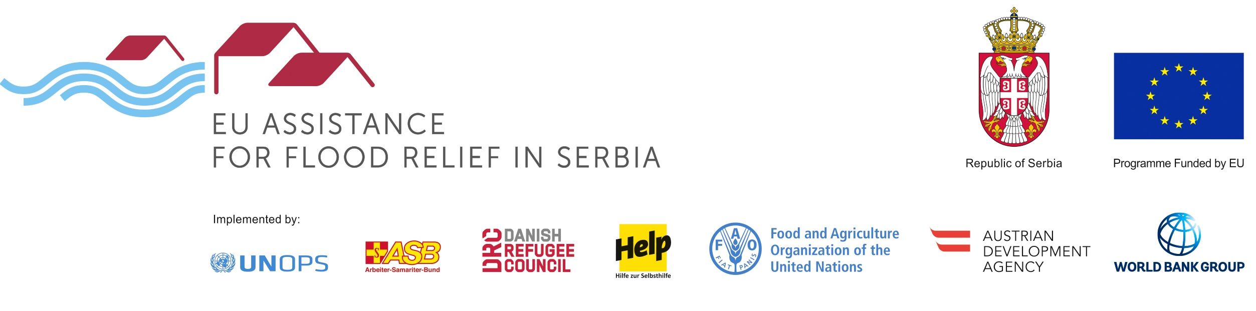

PROGRAMME: REHABILITATION OF FLOOD PROTECTION INFRASTRUCTURE
TENDER: REHABILITATION OF OBRENOVAC´S AND SURČIN´S NETWORKS OF DRAINAGE CHANNELS
REFERENCE: RFPI 09 2016

The Austrian Development Agency (acting on behalf of the public water management company Beogradvode as Investor) intends to award a works contract for the rehabilitation of drainage channels (dredging of silty material) with financial assistance from the European Union. The open tender procedure is conducted pursuant to the provisions of the Austrian Federal Act on Public Procurement (Bundesvergabegesetz).
The official tender notice is published on https://www.auftrag.at/eTender.aspx?id=B6550A51-5143-44FD-BDB3-BD6DE1B131&action=show&AspxAutoDetectCookieSupport=1&lang=en-us. The tender dossier can be downloaded under this link after registration.
Possible additional information, addenda or clarifications shall be published on https://www.auftrag.at/eTender.aspx?id=B6550A51-5143-44FD-BDB3-5ABD6DE1B131&action=show&AspxAutoDetectCookieSupport=1&lang=en-us.
Contact Point/further information: WOLF THEISS Rechtsanwälte GmbH & Co KG, e-mail: lubica.palenikova@wolftheiss.com , fax: +43 1 515 10 665354
Location of the works: Obrenovać and Surčin in Serbia.
CPV codes: 45246400 and 45252124.
Deadline for submission of tenders: 25 October 2016, 11:00 a.m. at WOLF THEISS Rechtsanwälte GmbH & Co KG in Schubertring 6, 1010 Vienna.
Opening of tenders: 25 October 2016, 11:30 a.m. at WOLF THEISS Rechtsanwälte GmbH & Co KG, Schubertring 6, 1010 Vienna, Austria.

